
UNIT TEST (2023-24)
Subject: Informatics Practices(H)  Grade: XII |  | Max. Marks: 35  Time: 1 Hr 15 Mins
 | SECTION A |  |  | (9)
1. | An organization purchase new computers every year and dumps the old one into the local dumping yard. Write the name of the most appropriate category of waste that the organization is creating every year, out of the following options: |  |  | 1
 | - Business waste |  | - Commercial waste
 | - E-waste |  | - Green Waste
2. | A computer network created by connecting the computers of your school’s computer lab is an example of |  |  | 1
 | - LAN |  | - MAN
 | - WAN |  | - PAN
3. | Legal term to describe the right of creator of original creative or artistic work is called__________. |  |  | 1
 | - Copyright |  | - Copyleft
 | - GPL |  | - Trademark
4. | Which of the following statement is wrong in context of DataFrame? |  |  | 1
 | - Two dimensional, size is Mutable
 | - Can perform Arithmetic operators on rows and columns.
 | - Homogeneous tabular data structure
 | - Create Dataframe from numpy ndarray
5. | Unsolicited commercial emails is known as …………..? i. Spam ii. Malware iii. Virus iv. Worm |  |  | 1
 | - spam |  | - virus
 | - malware |  | - worm
6. | which protocol allow us to have voice calls over the internet? i. HTTP ii. VoIP iii. Video Chat iv. SMTP |  |  | 1
 | - HTTP |  | - VoIP
 | - Video Chat |  | - SMTP
7. | Stealing someone else’s intellectual work and representing it as own is called ____________ . |  |  | 1
 | - Identity theft |  | - Plagiarism
 | - Phishing |  | - Pharming
8. |  |  |  | 1
9. |  |  |  | 1
10. | Assertion (A): DataFrame has both a row and column index.  Reasoning (R): .loc() is a label based data selecting method to select a specific row(s) or column(s) which we want to select.
 | - Both A and R are true and R is the correct explanation for A
 | - Both A and R are true and R is not the correct explanation for A
 | - A is True but R is False
 | - A is false but R is True
 | SECTION B |  |  | (12)
11. | What will be the output of the following python program  import pandas as pd  d1={'Name':['sapna','anmol','rishul','sameep'],  'Agg':[56,67,75,76], 'Age':[16,10,16,19]}  df=pd.DataFrame(d1)  print(df) |  |  | 2
 | 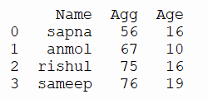
12. | What is IPR? Why should it be protected? |  |  | 2
 | Intellectual property rights are the rights given to persons over the creations of their minds like creativity concepts, inventions, industrial models, trademarks, songs, literature, symbols, names, brands,....etc. They also entitle him/her to prevent others from using, dealing or tampering with his/her product without prior permission from him/her. It should be protected since: 1. New innovations in all IPR domains lead to Human progress and advancement. 2. Legal protection of new innovations encourages safe spending on other innovations. 3. Caring for and protecting IPR contribute to achieving economic and social development.
13. | Explain the terms Static and dynamic Web pages. |  |  | 2
 | Static web page: In static web pages, Pages will remain same until someone changes it manually and information changes rarely. Dynamic web page: In dynamic web pages, Content of pages are different for different visitors and information change frequently. 2 Mark for writing correct difference
14. | Carefully observe the following code:  import pandas as pd  D1={'S1': 'India', 'S2': 'Russia', 'S3': 'World'} D2={'School': 'EOIS', 'Place': 'Moscow'} data={1:D1,2:D2} df=pd.DataFrame(data)  print(df)  Answer the following  - List the index of the DataFrame df  - i. List the column names of DataFrame df |  |  | 2
 | i. The index labels of df will include 0,1 ii. The column names of df will be: a,b,c 1 mark for each correct answer
15. | Write a python code to create a DataFrame with appropriate column headings from the list given below: [[201,’Gurmeet’,95],[202,’Praveen’,89],[203,’Suman’,97],[204.’Yogesh’,91] |  |  | 2
import pandas as pd data=[[201,’Gurmeet’,95],[202,’Praveen’,89],[203,’Suman’,97],[204.’Yogesh’,91]]
df=pd.DataFrame(data,columns=['Rno','Name', 'Marks'])
1 mark for each correct python statement
16. | Write some of the health issues caused due to technology. |  |  | 2
17. | Data about colleges in Delhi University, number of courses they run for science, commerce and humanities are stored in a CSV file(DU.csv). Present it using a bar graph. |  |  | 2
 | SECTION C
18. | 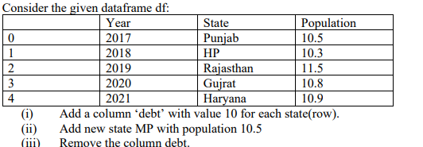 |  |  | 3
19. | What do you understand by Net Etiquettes? Explain any two such etiquettes. |  |  | 3
 | Net Etiquettes refers to the proper manners and behavior we need to exhibit while being online. These include : 1. No copyright violation: we should not use copyrighted materials without the permission of the creator or owner. We should give proper credit to owners/creators of open source content when using them. 2. Avoid cyber bullying: Avoid any insulting, degrading or intimidating online behavior like repeated posting of rumours, giving threats online, posting the victim’s personal information, or comments aimed to publicly ridicule a victim. Or any other relevant answer. 1 ½ marks for definitions of Net Etiquettes 3 1 ½ mark each for the example with explanation
20 | Write any 2 differences between Star and Bus topology?
 | 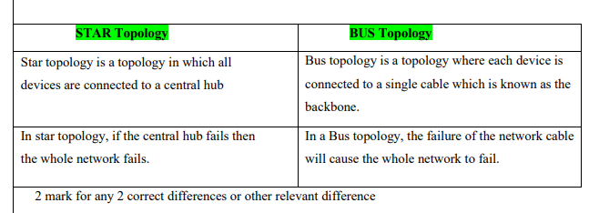
21.
 | SECTION D |  |  | (14)
22. | i) Mr. Summit, a data analyst has designed the DataFrame df that contains data about Computer infrastructure with ‘S01’, ‘S02’, ‘S03’, ‘S04’, ‘S05, ‘S06’ as indexes shown below. Answer the following questions:  a) df.shape  b) df[2:4]  ii) Write Python statement to display the data of working column of indexes S03 to S05.  iii) Write Python statement to compute and display the difference of data of computers column and working column of the above given DataFrame. |  |  | 4
 | i) Output A) (6,4) B) school computers non-working working S03 JPS 25 4 21 S04 APS 45 6 39 1 mark for each correct output ii) Python statement: print(df.loc[‘S03’:’S05’, ‘working’]) OR print(df.computers – df.working) 2 mark for correct python statement. (4) 0-O-o- End of Paper –
23. | Observe the following figure. Write the python program for obtaining this as output. . Also give suitable python statement to save this chart  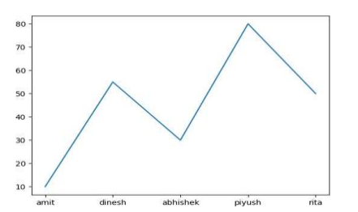 |  |  | 5
import matplotlib.pyplot as plt
eng_marks=[10,55,30,80,50]
st_name=["amit","dinesh","abhishek","piyush","rita"]
plt.plot(st_name,eng_marks)
plt.show()
plt.savefig("aa.jpg")
1 mark for correct import sattement 1 mark for correct declaration of marks and names 1 mark for correct use of plot method 1 mark for correct use of show method 1 mark for corect use of savefigmethod
24. | 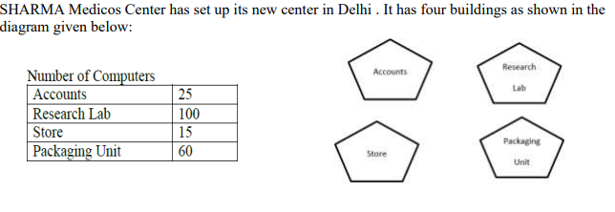  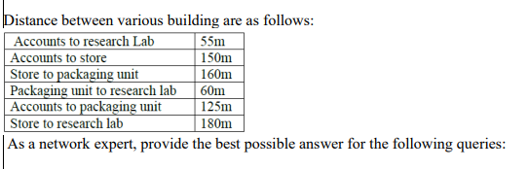  As a network expert, provide the best possible answer for the following queries:  - Suggest a cable layout of connections between the buidings  - Suggest the most suitable place (i.e building) to house the server of this organization.  - Suggest the placement of following devices with justification:  - Repeater b) Hub/Switch  - Suggest a system(hardware/softeware) to prevent unauthorised access to or from the network  - The company is planning to link its head office situated in Delhi with the offices in hilly areas.Suggest a way to connect it economically. |  |  | 5
Answer: i. 1 mark for correct layout
ii. Research Lab
iii. Repeater: Between Accounts and Store, Hub/Switch in each block
iv. Firewall
v. Radio Wave 1 mark for each correct answer or for any other relevant answer
***

